WORKSHEET 7 SQL

Q1. The primary key is selected from the

A. Composite keys

B. Candidate keys

C. Foreign keys

D. Determinants

Ans.b)candidate keys

Q2. Which is/are correct statements about primary key of a table?

A. Primary keys can contain NULL values.

B. Primary keys cannot contain NULL values…

C. A table can have only one primary key with single or multiple fields….

D. A table can have multiple primary keys with single or multiple fields.

Ans. B)Primary keys cannot contain NULL values

C) A table can have only one primary key with single or multiple fields

**Q3 to Q10 have only one correct answer. Choose the correct option to answer your question.**

Q3. Which SQL command is used to insert a row in a table?

A. Select

B. Create

C. Insert

D. Drop

Ans. C)Insert

Q4. Which one of the following sorts rows in SQL?

A. SORTBY

B. ALIGNBY

C. ORDERBY

D. GROUPBY

Ans. C) ORDERBY

Q5. The SQL statement that queries or reads data from a table is

A. QUERY

B. READ

C. SELECT

D. QUERY

Ans. C)Select

Q6. Which normal form is considered adequate for relational database design?

A. 1NF

B. 2NF

C. 3NF

D. 4NF

Ans. C) 3NF

Q7. SQL can be used to

A. Create database structures only

B. Modify database data only

C. All of the above can be done by SQL

D. Query database data only

Ans. D) Query database data only

Q8. SQL query and modification commands make up

A. DDL

B. DML

C. HTML

D. XML

Ans. B) DML

Q9. The result of a SQL SELECT statement is a(n).

A. File

B. Table

C. Report

D. Form

Ans B) Table

Q10. Second normal form should meet all the rules for

A. 1 NF

B. 2 NF

C. 3 NF

D. 4 NF

**Ans.B) 2NF**

**Q11 to Q15 are subjective answer type questions, Answer them briefly.**

Q11. What are joins in SQL?

Ans SQL Join statement is used to combine data or rows from two or more tables based on a common field between them

Q12. What are the different types of joins in SQL?

Ans. the different types of the JOINs in SQL:

* (INNER) JOIN: Returns records that have matching values in both tables
* LEFT (OUTER) JOIN: Returns all records from the left table, and the matched records from the right table
* RIGHT (OUTER) JOIN: Returns all records from the right table, and the matched records from the left table
* FULL (OUTER) JOIN: Returns all records when there is a match in either left or right table

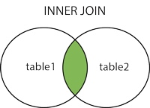  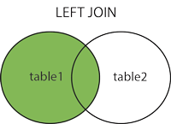  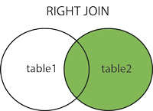  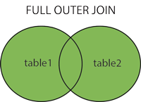

Q13. What is SQL Server?

Ans. SQL Server is a relational database management system, or RDBMS, developed and marketed by Microsoft.

Similar to other RDBMS software, SQL Server is built on top of SQL, a standard programming language for interacting with relational databases. SQL Server is tied to Transact-SQL, or T-SQL, the Microsoft’s implementation of SQL that adds a set of proprietary programming constructs.

SQL Server works exclusively on the Windows environment for more than 20 years. In 2016, Microsoft made it available on Linux. SQL Server 2017 became generally available in October 2016 that ran on both Windows and Linux.

Q14. What is primary key in SQL?

Ans The PRIMARY KEY constraint uniquely identifies each record in a table. Primary keys must contain UNIQUE values, and cannot contain NULL values. A table can have only ONE primary key; and in the table, this primary key can consist of single or multiple columns (fields).

Q15. What is ETL in SQL?

Ans. ETL, which stands for extract, transform and load, is a data integration process that combines data from multiple data sources into a single, consistent data store that is loaded into a data warehouse or other target system